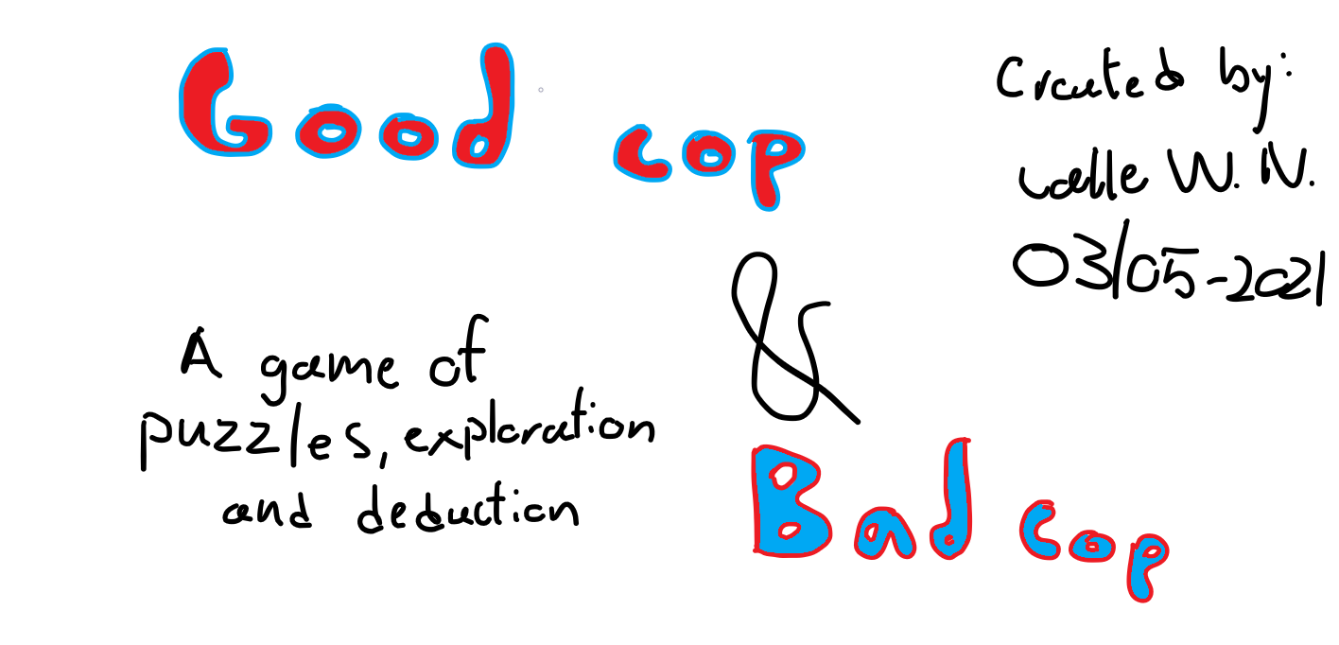

**Table of Contents**

1. Game overview……………….………………………………………………………........3

1.1 Game Concept

1.2 Target Audience

1.3 Pedagogical Objectives

1.4 Gameflow Summary

1.5 Look and Feel

1.6 Pedagogical Scenario

1. Gameplay & Mechanics……………………………………………..………………….…..4

2.1. Mechanics

2.2. Game Options

2.3. Constraints due to the Pedagogical Objective

1. Story, Setting & Character…………………………………………………………………..6

3.1. Story and Narrative

3.2. Game World

3.3. Characters

1. Levels……………………………………………………..…………………………………..7

4.1. Levels

4.2. Training Level

4.3. Assessment

1. Interface……………………………………………………………………………………….9

5.1. Visual System

5.2. Control System

5.3. Audio, music and sound effects

5.4. Help System

1. Extras………………………………………….……………………………………………...9

6.1. Cheat

6.2. Easter eggs

6.3. Pop-culture references

1. **Game Overview**

1.1. Game Concept

Two cops, two stories, one case. John McHane and Simon Hallaway are two police officers in different times that are working the same case. Puzzles, time travel and interconnection between two stories are the core of this game.

1.2. Target Audience

The target audience is those curious, problem-solvers who can see from different perspectives and extrapolate data which may or may not be completely true. Police work, and time travel.

1.3. Pedagogical objective(s)

The pedagogical objectives of the game is to entice exploration, problem-solving & deduction in order to solve puzzles and progress through the story. The game also allows for gruesome scenes due to its pixelated visual style, thus remaining a somewhat high level of narrative realism whilst remaining visible faulsity.

1.4. Game Flow Summary

As the player progresses the case as Simon Hallaway they might get stuck on a detail or lack certain descriptors to solve puzzles, then they can transfer back into John’s perspective and find those details or clarify something to themselves. There are no objectives in the game other than *solve the case*. However through exploration the players might find vague objectives or more on the nose. The game really alternates between the perspective of John and Simon, culminating in the solution of the sinister case & the **real** explanation for why John was alleviated from the task force & his vanishing.

1.5. Look and Feel

The look and feel of the game is reminiscent of the retro *Monkey Island* games. As few UI elements as possible are used. The scenes might be gruesome and some are outright disgusting. Other scenes are clean and professional such as the police station. In John McHane’s perspective the world looks brown, grey and dark (noir-style), when the player plays through Simon Hallaway’s perspective the world is instead colourful and filled with neon-lights (cyberwave/70’s).

1.6. Pedagogical scenario

The game inserts itself into the pedagogical scenario by applying advanced puzzles and problem-solving. The range of puzzles and different obscure solutions will adhere to the pedagogical objective by progressing the narrative and rewarding the player with more information and incentive to continue progressing.

1. **Gameplay & Mechanics**

2.1. Mechanics

2.1.1. Movement

There is no quick-travel. Travelling the city works like travelling in the Monkey Island games, where the player can move anywhere and open up more areas as the game progresses. Sometimes the player may need to return to a scene and sometimes they cannot return after certain actions have been done (note: the player can never be permanently locked out of a necessary area but might have to perform a side-objective to regain access).

2.1.2. Actions

There are 10 general actions outside of walking that the player can perform. Most of these items are related to items either in the player’s inventory or present by a scene.

* Give [Item name] to [NPC name]

Give a particular item to a particular NPC. Either as a favour or to progress the main story. More often than not this will lead to the loss of an item.

* Pick up [Item/Object name]

Pick up a particular item. If the player tries to pick up an item, it will go to their inventory otherwise the player character picks it up and nothing can be interacted with until it has been put down again.

* Use [Item name]

Use up a particular item. This action changes name depending on what item is prompting it (i.e. A bottle of water would not prompt “Use Water Bottle” but rather “Drink Water from bottle”) sometimes several uses for any item is present, then they will all show up as options for the player to use. Some items can only be used in conjunction with another item or object, such as a key.

* Open [Item/Object name]

Opens a container or door. This may sometimes prompt a fail message if it cannot currently be opened under any circumstance.

* Investigate [Item/Object/NPC name]

Pretty much every item, object and NPC can have this action performed on them. This action will prompt the player character to talk about whatever is investigated. Sometimes this will open up new options if the player character discovers new information upon closer inspection.

* Push [Object/NPC name]

Push an object or NPC. Pushing an object might cause it to move or interact with the environment. Pushing an NPC will make them upset but might be beneficial for their well-being or just be rude.

* Close [Container/Object name]

Closes a container or door. This may sometimes prompt a fail message if it cannot currently be closed under any circumstance.

* Talk to [NPC name]

Prompt new dialogue to the NPC. Sometimes there are just flavour conversations or one-liners. Other times there are multiple options which leads to a more prominent dialogue.

* Pull [Object/NPC name]

Pull an object or NPC. Pulling an object might cause it to move or interact with the environment. Pulling an NPC will make them upset but might be beneficial for their well-being or just be rude. After successfully pulling an NPC, intimidation should be more effective.

* Shoot [Item/Object/NPC name]

The player character brings out their gun and shoots an item, object or NPC. If the item or object breaks or takes damage the player character will reflect on this.

* Switch Perspective

The player shifts perspective between John McHane and Simon Hallaway if possible.

2.1.3. Economy

Each day the player (in Simon’s perspective) will be prompted to pick out the amount of gear they wish to carry for that particular day. The more gear they carry the less will be available for their fellow policemen and any damages to the gear will carry over to subsequent days. In John’s perspective he will always carry his own personal gear, which he will also repair between days making them visibly more worn.

2.2. Game Options

All of the game options are in the form of story progression. Unlike the Monkey Island games which often have on linear solution, the progression in this game have many branching paths making it possible to solve puzzles differently with different consequences. For example, a player could solve most puzzles without using John’s perspective, which would lead to Simon having less evidence for his case the longer the story progresses.

2.3. Constraints due to the pedagogical objective

The player will be encouraged to explore different paths of dialogue, unique and creative solutions to puzzles and clever detective work in order to solve the encounters the game throws at them. However, the players will be discouraged from being overtly rude and unhelpful to the NPCs as they will reflect that behaviour back onto the player.

1. **Story, Setting & Character**

3.1. Story and Narrative

The game is at its core a story-driven, mystery strategy game. The story presented to the player will be that of two perspectives: John McHane & Simon McHane. In the 40’s John McHane was tasked with investigating a particularly nasty serial killer case. The investigation got him wound up with a drug cartel within the city and he suddenly became endangered. John, not giving up on his assignment, kept investigating the case until a shot wound in the chest had him let go from the police force. John however, could not let go of the case and kept investigating in his own spare time. When John had almost solved the case he mysteriously vanished. The police force faked a story of him sacrificing his life in order to protect a fellow policeman.

Years later, Simon Hallaway graduates from the police academy and becomes a prominent member of the force. When Simon is investigating Mrs.McHane’s apparent suicide he stumbles upon lost notebooks and files from the late John McHane. Simon, upon reading the files feels that something is off. He takes it upon himself to look further into this case, and John McHane’s mysterious vanishing.

Was Simon alleviated due to his obsession with John McHane? Maybe John was not taken off the force? Perhaps something occult, or just a larger crime ring? That’s what the player will find out. Along with the secrets of John’s last case.

3.2. Game World

* The Game World is an alternative timeline planet Tellus by Sol. John McHane’s story takes place in the 40’s, noir & occult. Simon’s story takes place in the 70’s, vice & flashy.

3.3. Characters

* John McHane, 53 (during his perspective) - One of the main characters of the game. John McHane is a police veteran who has always excelled at solving mind-boggling cases. On his last case before the game begins (possibly the prologue mission) John was badly hurt and as such was let off the force, however McHane cannot let go of his job and keeps working on his cases despite his now civilian status.
  + Attributes: Aggressive, intimidating, scheming, intelligent, attentive.
  + Appearance: Rugged, short, greyish-haired, buff, leering
* Simon Hallaway, 28 - The 2nd main character of the game. Simon is John’s avenger and has found that one of the cases John said the department never solved is actually part of a much larger, more sinister organization, the solution of which could forever change the crime-scene in the city.
  + Attributes: Calm, calculating, persuasive, subtle, colour-blind
  + Appearance: Fixed, tall, blond-hair, lanky, focused

1. **Levels**

4.1. Levels

There are 4 acts in the game with 3 levels each. These levels contain 2-4 encounters and many more puzzles. Each level will be presented by one of the two main characters with information about what is going on, how it develops the story and problems the player may (or may not) face in the level. All aspects the player hasn’t experienced previously are explained via pop-ups and dialogue with NPC’s and monologue with the main characters. An objective tracker will be present with vague clues or clear objectives. Each act will reveal one large truth about the case of John McHane culminating in act 4 with a big reveal.

***Act 1*. *Tutorial***

*Level 1: The Case*

* Narrative: Simon is taking on his first case after graduating police academy. A homicide case regarding a known drug-dealer and police informant. Simon will have to go through some bad neighbourhoods in order to find out what happened.
* Objective: Uncover which of the suspects are most likely to have committed the murder of the informant.
* Mechanics: Simple puzzles & social encounters.

*Level 2: The Chase*

* Narrative: John McHane is on the chase after an informant gone rogue. He is suspected to have acted as a double-agent which could be detrimental to the police force. John has to find the rogue informant and know what information he has given out before the thugs of the street grows bolder.
* Objective: Find the rogue informant and teach him a lesson.
* Mechanics: Simple “combat” & social encounters.

*Level 3: The Vase*

* Narrative: The first mission in which both characters work on a similar case. John has been tasked to return a vase which was stolen from the local museum. Simon is tasked with interviewing an art thief who was put into prison many years ago in an attempt to find the culprit to some recent burglaries of art.
* Objective: Use the clues found in both John and Simon’s perspectives to solve the case of the missing vase.
* Mechanics: Perspective swapping and relationship puzzles.

For the following acts there will not be a summary as the kinks are being worked out in the story itself. As a general rule of thumb each of the acts will attempt to introduce new puzzles and obstacles for the player to overcome. 1-2 additional tasks will be added for each level in order to increase complexity without overwhelming the player.

***Act 2. Mrs. McHane***

*Level 1: The Suicide*

*Level 2: One Peculiar Man*

*Level 3: Murder*

***Act 3. What’s left of his work***

*Level 1: On the Trail*

*Level 2: Rock n’ Roll n’ Drugs*

*Level 3: There’s Something Else*

***Act 4. The plot thickens***

*Level 1: Obsession*

*Level 2: He Was(n’t) Wrong*

*Level 3: Conclusion*

4.2. Training level

The first act works as a tutorial for all the aspects in the game. *Level 1: The Chase* details the basics of dialogue and puzzling that the player will encounter from Simon’s perspective. *Level 2: The Chase* will continue to explore the puzzles and narrative from John’s perspective. *Level 3:* *The Vase* will be the first time the player gets freedom to put what they have learnt from level 1 & 2 to practice and also the first time the player is allowed to freely switch between John and Simon’s perspective using their combined knowledge to pass through the scenario.

4.3. Assessment

The player will have to be clever with dialogue, visual puzzles in order to proceed the story forward and finding all the details and secrets hidden throughout the levels. At the end of each level the player will be shown how much of the content they experienced. Certain endings require specific secrets to be found and sometimes a dialogue early in the game can impact the future dialogue with an NPC.

1. **Interface**

5.1. Visual system

The game is played in 2D. With a minimal HUD to fit as much information on the screen at any given time almost like a canvas. All actions can be displayed via an action wheel (by holding Left-Click and dragging the cursor to the action the player wishes to perform) or accessed by pressing 0-9 on their keyboard. On the right-hand side there will be an objective tracker with vague objectives and hints if the player wishes for them. In the top right corner there will be a button for Options (default keybind: Esc) and a button to open up John’s Journal (default keybind: J). When the player participates in dialogue a HUD is displaying all possible dialogue options the player can perform and some of their predicted reactions, allowing the player to plan ahead of time.

5.2. Control system

The player moves around the game with their mouse (default: Left-click). Interacting with objects can be done either with the mouse (clicking on an object to open up possible actions) or with the keybinds mentioned in 6.1.

5.3. Audio, music & sound effects

The sound should reflect the character. When in John McHane’s perspective the music will be more jazzy and have a lot of vinyl crack as to represent the 40’s. The audio and sound effects will be inspired by old 40’s noir movies. John’s audio should also be in mono to further increase the sense of old-times.

Simon Hallaway’s audio should represent the 70’s. The music will be synthetic and have a solid beat throughout, with clean long-drawn tones. The sound effects should sound flashy and almost a tad sci-fi as to represent the fascination of space at the time. Simon’s audio should be as high quality as possible with stereo output.

5.4. Help System

Story mode can be toggled via the pause menu. Story mode will highlight components to the puzzles after a period of idleness. Story mode will also show tips for certain encounters and dialogue options.

1. **Extras**

6.1. Cheats

By experimenting with a particular set of actions onto obscure objects might trigger certain cheats or easter eggs. (Ex. highlight all important objects and actions)

6.2. Easter eggs

If the player completes the game without playing as John whatsoever they will be treated to the secret ending in which Simon’s spouse believes that Simon is making it all up and gets him into therapy. If the player opens/closes the door at the police station 10+ times as John, it will squeak in Simon’s perspective which he will happily point out.

6.3. Pop-culture references

Pop-culture references will be scattered throughout both perspectives, of course referencing their respective time periods. In backgrounds, dialogue, NPCs etc. Some references may be more modern time, but inserted tastefully as not to cause ludonarrative dissonance.

*Calle Wahlstedt Nilsson*

*03/05/2021*